

A Web Design Development Project
Presented to
the Faculty of the College of Computer Studies Our Lady of Fatima University
In Partial Fulfillment
of the Requirements for the
WBDV111 – Web Development with Lab I
by
Adrian Herson .T amigo
April 2026
TABLE OF CONTENT



Title Page ….………………………………………………… i

1 | Executive Summary
 | 1.1 Project Overview | 1
 | 1.2 Target Audience | 2
 | 1.3 Project Objectives | 3
 | 1.4 Statement of the Problem | 4
 | 1.5 Scope and Limitations | 5
2 | Introduction and Project Background
 | 2.1 Business or Company Profile | 6
 | 2.2 Rational of the Werb Design Project | 7
 | 2.3 Significance of the Project | 8
3 | Planning and Design
 | 3.1 Website Category and Concept | 9
 | 3.2 Design Goal and Visual Strategy | 10
 | 3.3 Site Map and Information Architecture | 11
 | 3.4 Wireframe and Page Layouts | 13
 | 3.5 Navigational Design | 14
4 | Design Implementation
 | 4.1 Homepage Design | 15
 | 4.2 Inner Pages Design | 20
 | 4.3 User Interface Design Elements | 21
 | 4.4 User Experience Consideration | 22
 | 4.5 Branding and Visual Consistency | 23
 | Summary, Reflection and Recommendations
 | 5.2 Project Summary | 24
 | 5.2 Self- Reflection | 25
 | 5.3 Future Design Improvements | 26



1 Executive Summary
1. Project Overview 1 2 Target Audience .3 Project Objectives .4 Statement of the Problem .5 Scope and Limitations 5 Introduction and Project Background
2.1 Business or Company Profile 6 2.2 Rational of the Web Design Project 7 5.2 Self- Reflection 25 5.3 Future Design Improvements 26


1. Executive Summary
.1 Project Overview:This project focuses on the design and development of a website for KAPEHOT, a coffee shop with years of experience in serving high-quality coffee and beverages. The website acts as the business’s digital presence, compiling essential information including the shop’s background, product offerings, services, and contact details. It is built to be clear, accessible, and visually engaging, serving as a central platform that introduces KAPEHOT to both existing and potential customers. By making key information available online, the website allows users to learn about what the shop offers at any time and from anywhere, helping to strengthen brand awareness and improve customer accessibility.


1.2 Target Audience:The target audience includes coffee lovers and enthusiasts, students, working professionals, local residents, and visitors seeking a welcoming space to enjoy quality coffee, relax, or hold casual meetings. These groups typically value convenience, clear information, and an inviting atmosphere—both in-person and online. The website is designed to meet their needs by presenting content in an easy-to-navigate format, ensuring that whether they are looking for menu details, location, or background about the shop, they can find what they need quickly and effortlessly.
1.3 Project Objectives: To develop a functional and well-structured website that effectively showcases the identity and range of offerings of KAPEHOT.
To provide easy access to key details such as the shop’s background, services, menu items, and contact information.
To create a design that captures and reflects the warm, classic, and inviting atmosphere of the coffee shop.
To strengthen the business’s online visibility and make it simpler for customers to engage and connect with the shop.
To ensure the website is easy to navigate and user-friendly, catering to the needs of all types of visitors.
1.4 Statement of the Problem: At present, KAPEHOT does not have an official online platform where customers can conveniently obtain information about the business. Those who are interested often have to visit the physical shop or ask others just to find out about available products and services, or to learn basic details like operating hours and location. The absence of an online presence limits the shop’s reach, as it cannot effectively connect with people who use the internet to search for food and beverage businesses. This results in missed opportunities to attract new customers and expand its customer base.

1.5 Scope and Limitations: Scope This project involves the design and development of essential web pages, specifically the Home, About, Menu, and Contact pages. It centers on presenting comprehensive information about the business, including its background, product selections, and services. The website will also feature a layout and visual design that aligns with the brand theme and identity of KAPEHOT, ensuring a consistent and recognizable representation of the coffee shop.
Limitations: he website is intended primarily as an informational platform and does not include advanced functionalities such as online ordering systems, online payment processing, or real-time updates on product stock availability. All content presented is based on the information and details provided regarding the business, and the website is designed solely for viewing and reference purposes.
2. Introduction and Project Background
KAPEHOT is a well-established local coffee shop that has been serving the community since 2025. Over the years, it has built a solid reputation for offering premium coffee blends, delicious food selections, and warm, welcoming service. The shop takes pride in preserving traditional coffee preparation methods while continuously adapting to suit modern tastes and preferences. It has become a favorite gathering spot for people from all walks of life — from students seeking a quiet place to study and professionals taking a break, to groups of friends catching up. Thanks to its rich heritage and consistent quality, KAPEHOT has earned its place as a trusted name in the local food and beverage industry.

2.2 Rationale of the Web Design Project: Creating a website for KAPEHOT is essential in today’s digital-driven world, where the majority of people search for business-related information online. At present, the shop depends entirely on its physical location and word‑of‑mouth referrals to reach customers — a setup that limits its visibility and accessibility. By developing a dedicated website, we can establish an official platform where visitors can easily access details such as the shop’s background, menu, services, and operating hours at any time and from anywhere. This initiative also enables the business to keep pace with current market trends, expand its reach to a broader audience, and effectively showcase its long-standing legacy and quality offerings.

2.3 Significance of the Project: For the Business: This project will greatly benefit KAPEHOT in multiple ways. It will enhance the shop's brand visibility and recognition, making it easier to reach a wider audience and attract new customers. By providing up-to-date information on products, services, and promotions, it will also help keep existing customers engaged and informed. The website will serve as a professional digital representation of the business, reinforcing its reputation for reliability, quality, and long-standing presence in the industry. Moreover, it will allow the shop to stay competitive in the digital age, opening up opportunities for growth and expansion.
3. Planning and Design
3.1 Website Category and Concept: This is a Business Informational Website, developed primarily to present comprehensive details about the business — including its background, products, and services — in a clear and accessible manner for all visitors. Its main purpose is to serve as a reliable online reference where users can easily find relevant information about KAPEHOT.

3.2 Design Goals and Visual Strategy:
Design Goals
To develop a clean, well‑structured, and intuitive layout that enables users to locate information quickly and efficiently.
- To effectively reflect the brand’s identity and rich history through the consistent application of colors, typography, and visual elements.
- To maintain a balance between visual appeal and functionality, ensuring the design is both creative and practical to use.
- To make the website accessible and easy to read for all visitors, regardless of their level of technical knowledge or experience.
Visual Strategy
- Incorporate high‑quality images of coffee beans, freshly brewed beverages, and the shop’s interior to create an immersive online experience and vividly showcase what the business has to offer.
- Select clear, legible fonts that align with the classic‑yet‑modern theme — simple enough for comfortable reading, yet stylish enough to preserve and highlight the brand’s distinct character.
- Apply a unified color palette consistently across all web pages to create visual harmony and strengthen brand recognition.
- Organize content in a logical manner, placing key information and navigation controls in prominent, easy‑to‑reach areas so users can browse through the website smoothly and effortlessly.

3.3 Site Map and Information Architecture:
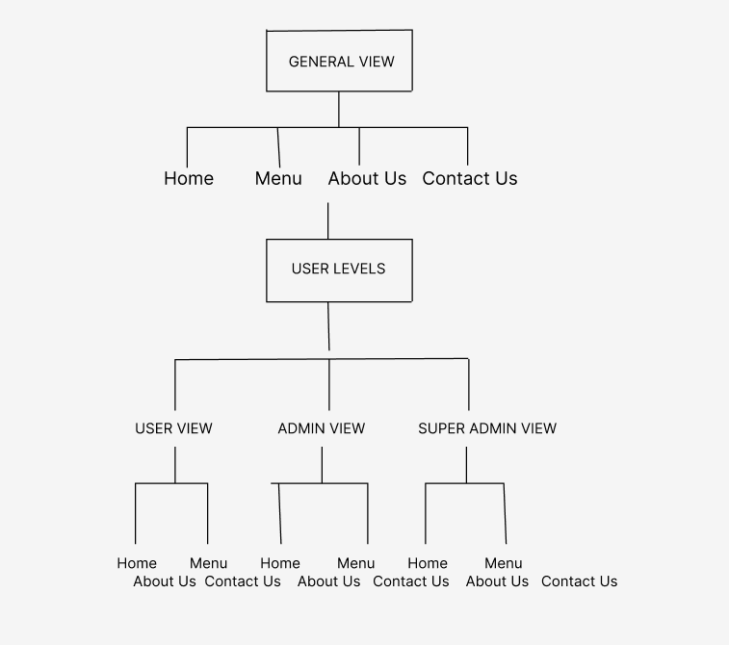

3.4 Wireframes and Page Layouts:
Figure: 1

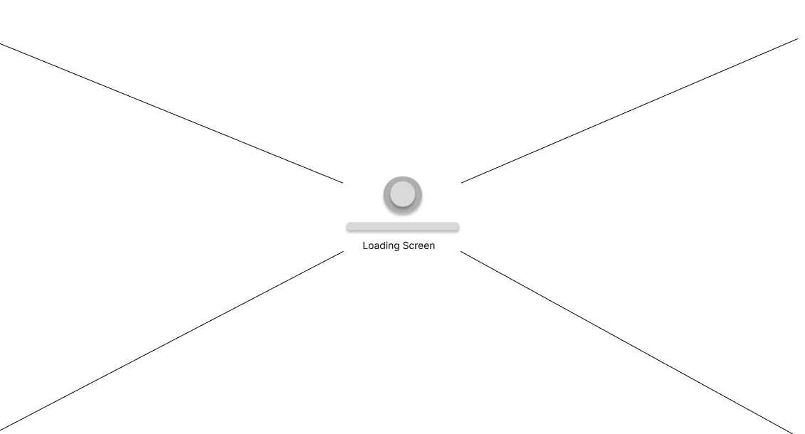

Figure: 2
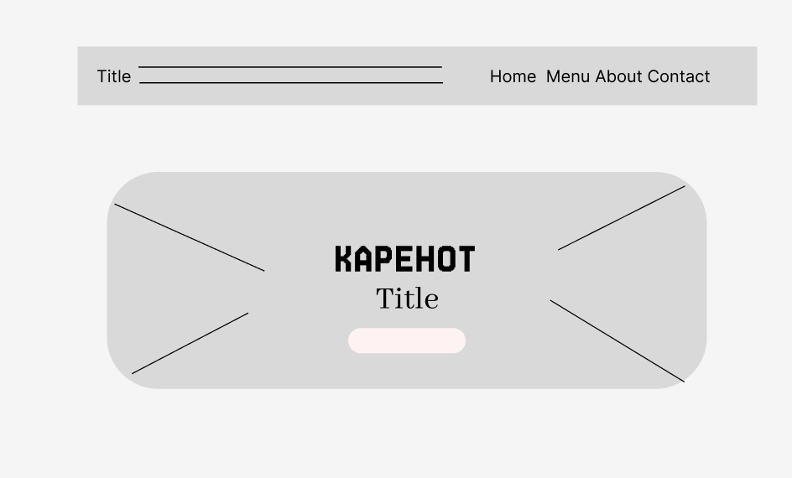

Figure: 3
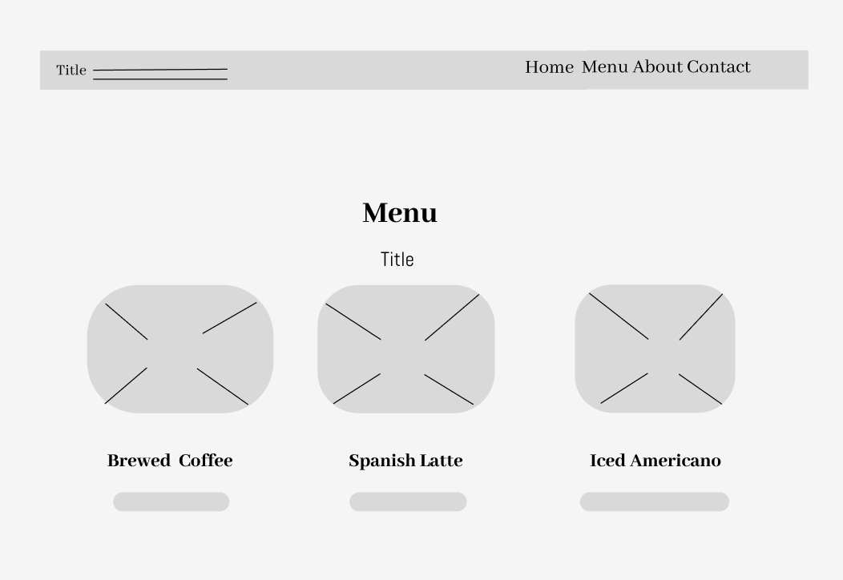

Figure: 4
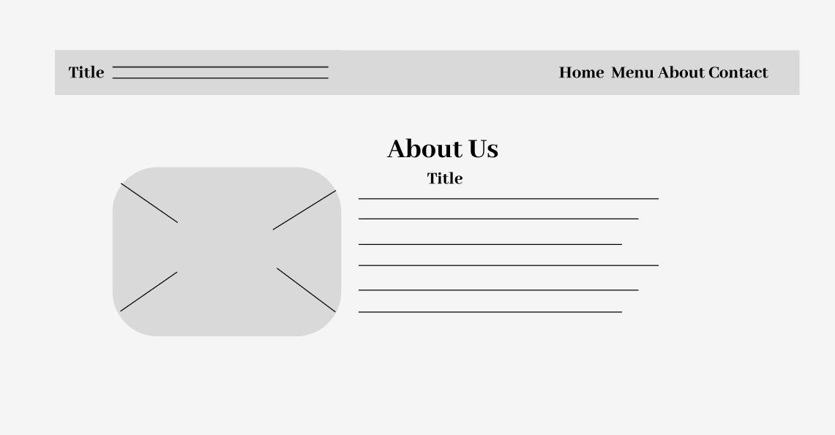

Figure: 5
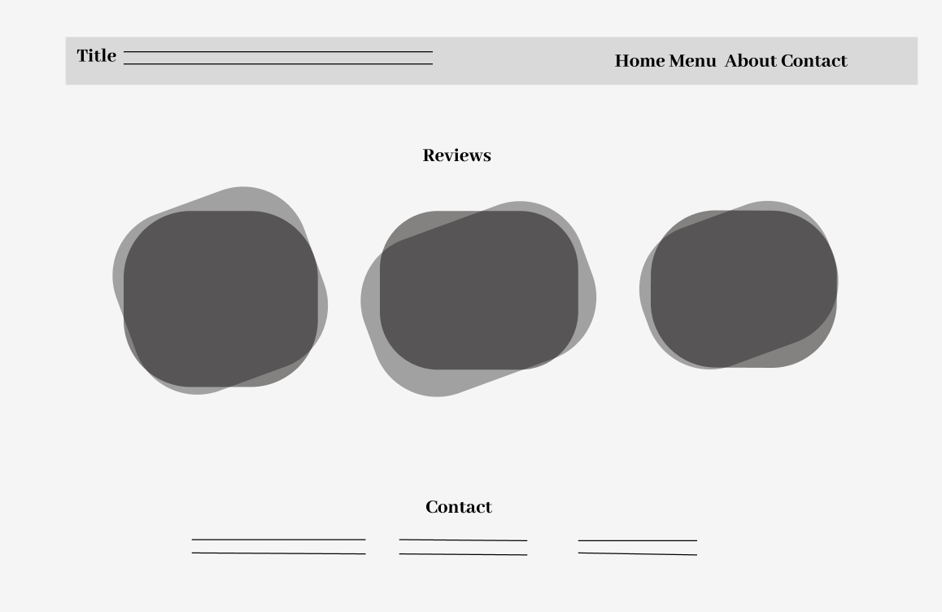
3.5 Navigation Design:A horizontal navigation bar is placed at the top of every page, containing direct links to all main sections of the website. Hover effects are applied to highlight each menu item, making it clear which section the user is about to select and improving the overall browsing experience. The navigation menu remains fixed and visible even when users scroll down the page, allowing them to move between sections at any time without needing to return to the top. All labels are clear and straightforward — including Home, Menu, About, and Contact — ensuring visitors can easily understand what type of information each section contains.

4. Design Implementation
4.1 Homepage Design: The homepage features a large, prominent carousel section with an overlay text stating "SINCE 2025", immediately highlighting the long history and established reputation of KAPEHOT. Following this visual introduction are dedicated sections titled "Our Story" and "Our Vision". These sections present the background, values, and future goals of the business, helping to build trust and create a meaningful connection with visitors by showing the brand’s authenticity and commitment to quality
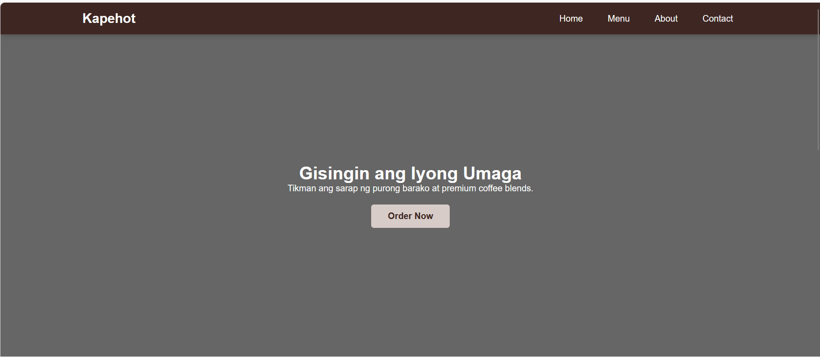

4.2 Inner Pages Design:
Menu Page
To showcase the variety of coffee and beverage offerings available, presenting each item with clear images, names, and prices. It helps users easily browse through the products, learn about what is being offered, and make informed choices based on their preferences.
About Us Page
To share the story, vision, and background of Kapehot, giving visitors a deeper understanding of the brand, its values, and its commitment to providing high‑quality coffee. It establishes a connection with users by explaining the journey from sourcing to serving every cup.
Contact Us Page
To offer users all necessary communication channels — such as contact number and location details — for inquiries, feedback, assistance, or collaboration. It also clearly displays the shop’s physical address and contact information for easy reference and accessibility.

4.3 User Interface (UI) Elements
User Interface (UI) elements serve as the fundamental components that make up the visual appearance and interactive features of the website. Each element is carefully designed to be clear, functional, and consistent in style, behavior, and placement across all pages. This uniformity ensures that users can easily recognize, understand, and interact with every part of the system, resulting in a smooth, intuitive, and enjoyable browsing experience. The color palette, typography, buttons, and layout are all chosen to reflect the warm and inviting identity of Kapehot, while maintaining clarity and ease of use.

4.4 User Experience (UX) Considerations
User Experience (UX) focuses on how visitors interact with and perceive the website. All design decisions are made to ensure the system is intuitive, accessible, efficient, and satisfying to use. Navigation is kept simple and direct, allowing users to find information quickly without confusion. Content is organized logically, with clear headings, readable text, and high‑quality images that support understanding and engagement. The overall flow is designed to guide visitors seamlessly from one section to another, making their visit convenient, pleasant, and memorable.

5. Summary, Reflection, and Recommendations
● 5.1 Project Summary: This project covered the complete process of planning, designing, and developing a functional and user‑friendly website for KAPEHOT. It includes essential pages such as the Home Page, Menu Page, About Us Page, and Contact Us Page. The design approach focused on creating a clear information structure, intuitive navigation, and consistent branding, while always putting user needs and experience at the forefront.
The website is built to serve all visitors by providing easy access to information about the shop, its coffee offerings, its story, and ways to get in touch. Through careful planning of user interface elements, application of UX principles, and adherence to branding standards, the final output successfully achieves its goal of being accessible, fully functional, and visually appealing.
Key features of the website include well‑organized content presentation, simple and clear navigation, attractive product displays with images and pricing, and direct communication channels including location and contact number. Overall, the project successfully combines effective design principles and solid technical implementation to deliver a complete, reliable, and effective web solution for the business.

5.2 Self Reflection
1. The Creative Process
.Why did you choose this specific category for your website?
I chose to create a website for a coffee shop because coffee is an essential part of daily life and culture in the Philippines — it brings people together, serves as a source of comfort, and is deeply loved by many. I noticed that while there are many coffee businesses, having a well‑designed online presence helps a shop stand out, reach more customers, and share its story and offerings more effectively. The category also offers great opportunities for creative design, from choosing warm and inviting color schemes to showcasing products in an appealing way. Through this project, I wanted to build a platform that not only promotes the business but also reflects the warmth, quality, and passion behind Kapehot — making it easy for visitors to learn about the shop, view the menu, and get in touch.
2. Technical Growth
- Which CSS property or HTML tag was the most difficult to master, and how did you figure it out?
- Among all the elements and styles I used, the most challenging to master was the CSS Flexbox layout properties — specifically display: flex, justify-content, and align-items. At first, I found it confusing how these properties affect the arrangement of elements, especially when trying to align items both horizontally and vertically at the same time. I often ended up with elements that were either overlapping, spaced incorrectly, or not positioned the way I intended — which was especially noticeable when designing the navigation bar and the product display sections of the website.
To overcome this, I started by studying clear tutorials and guides that explained how Flexbox works step‑by‑step. I also practiced by creating small test codes where I experimented with different values and observed how each change affected the layout. Whenever I encountered a problem, I inspected the elements using the browser’s developer tools to see exactly how the styles were being applied and where I might have made a mistake. Through continuous testing, adjusting, and comparing results, I gradually understood how each property works and how to combine them effectively. Now, I can confidently use Flexbox to create clean, responsive, and well‑arranged sections across the website.

3. Problem Solving
- Describe one specific "bug" or error you encountered. What steps did you take to fix it? One specific error I encountered was with the display of product images and text alignment in the "Our Best Sellers" section. When I first added the images for Brewed Coffee, Spanish Latte, and Iced Americano, they appeared inconsistent — some images were stretched, others were cut off, and the product names and prices below them were not aligned properly. Sometimes the text would move too far to the left or right depending on the screen size, making the section look messy and unprofessional. This happened because I used fixed width and height values for the image containers, and I did not set proper rules for how the content should behave when the screen size changes.

4. Future Outlook
● On a scale of 1–10, how confident do you now feel writing HTML and CSS from scratch? Why? I would rate my confidence as 8 out of 10. I feel very comfortable writing HTML and CSS from scratch because, through this project, I have gained a solid understanding of how to structure content logically using HTML and how to effectively design, style, and arrange elements with CSS. I have learned various layout techniques, mastered the creation of responsive designs, and developed the ability to troubleshoot common issues that may arise during the development process.
I am rating myself an 8 instead of a 10 because I recognize that there are still advanced concepts and features I can learn and improve on — such as creating more complex animations, working with advanced CSS preprocessors, and applying optimized coding practices suitable for larger‑scale projects. Nevertheless, I am confident that with continuous practice and further learning, I will be able to enhance my skills even more and achieve full proficiency in the future.

5.3 Future Design Improvements: In the future, I would like to improve the website by adding more advanced and interactive features, such as:
Integration of a Real‑Time Inventory SystemAdding this system will enable the website to automatically update stock levels whenever products are purchased or restocked. Customers will be able to view accurate, up‑to‑date information regarding the availability of coffee, beverages, and other items at any time. It will also help the business manage supplies more efficiently, reduce the risk of selling out unexpectedly, and ensure that visitors only see items that are currently available. This feature will strengthen customer trust by making sure all information provided is reliable and current.

